**

***ETSI and its Role in Developing Telecommunications Standards for the EU and the World***

# **What is ETSI?**

ETSI standing for European Telecommunications Standards Institute was created in 1988 by the European Conference of Postal and Telecommunications Administrations, CEPT. It was not until 1992 however that ETSI began working on European Standards.

Today ETSI now works on standards worldwide with more than 800 members in 66 countries. ETSI has a good reputation as it is unbiased when dealing with members and are reliable. This good standing with members can also be from their status as a non-profit organization although the EU identifies ETSI as a part of European Standards Organisation, ESO.

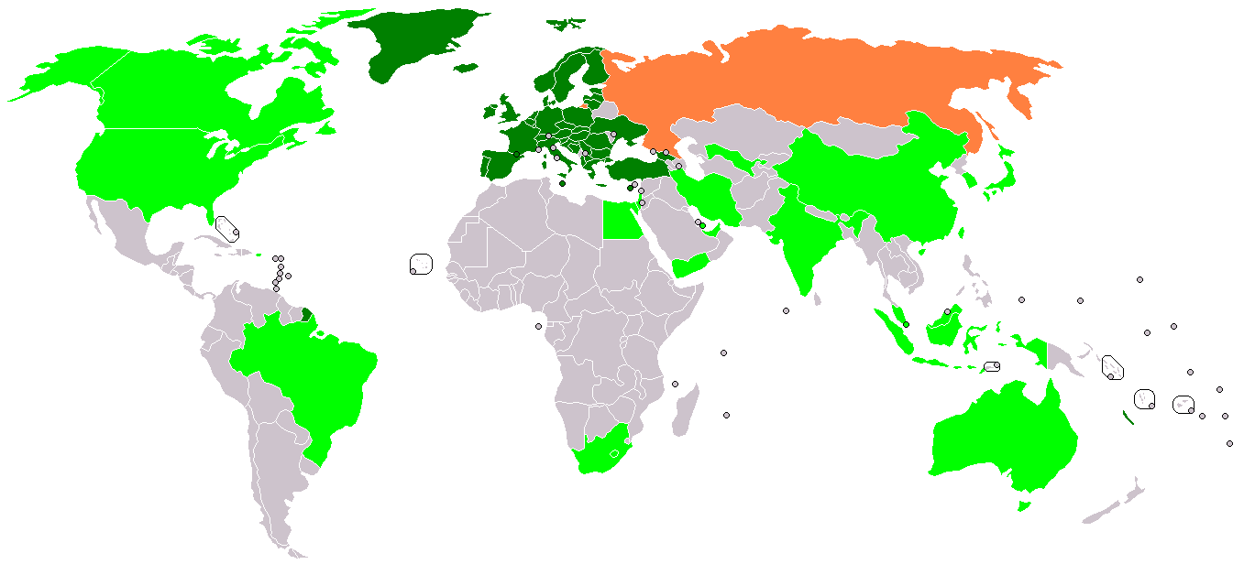



# **The Role of ETSI in Developing European Standards**

ETSI’s reason for existing is to create Standards for the Telecommunication industry such as manufacturers and operators. Since ETSI has started 30,000 standards have been created with almost 2500 produced on average each year.

ETSI is one of the three main organisations who deal with standards in Europe, the other two being CEN (European Committee for Standardisation) which deals with substances and construction and CENELEC (European Committee for Electrotechnical Standardization) dealing with standards in the electro-technical industrial field. Since the 90’s ETSI has been working together with the other groups through a shared agreement. This is beneficial as it reduces a repeat in similar subjects and increases productivity.

In 2013 a new agreement was published which allowed all three groups to create shared standards. Harmonised standards are the name given to standards which the ESO have produced. They are produced upon a demand from the European commission. Harmonised standards allow corporations to prove that their products meet the terms.

Europe being a single market really helps with the process of producing standards. This means that ETSI does not have to produce standard after standard for individual countries. Standards are very important for Manufacturers, Operators, Developers and Consumers. With the single market manufacturers can sell their products to other countries without the need to adapt the product giving a decrease in cost around Europe and allow their business to be open to a larger market. Manufacturers being able to sell around Europe then benefits Network operators and consumers as they have a wide range of equipment to choose from. Operators can increase their coverage and work with other operators. Those producing new products or services can use the standards as a tool to reduce risks.

National Standards Organisations, NSO, work very close with ETSI. 40 National standards organisations help ETSI with keeping in contact with member within their country, discussions on standards with businesses and votes on standards. NSO allows local businesses to be heard by ETSI and so acts as a bridge. For example, if any standards are contradictory then NSO takes this up with ETSI and makes certain that they are renewed.

Development process used for

standards by ETSI

ETSI’s standards making process is based on consensus (agreement between their members) and on directness. The members decide what to standardize, the timing and resources of the task and have the approval over the final draft’s outcome.

ETSI have been committed to producing top quality standards and with over 25 years of experience they have ensured that their standards are of a high quality and have been produced efficiently.

To create or update an existing standard it merely takes an agreement of a minimum of 4 members of ETSI. The whole membership of ETSI is then given the choice if they would like to endorse it or object to it. It is not only members of the ETSI who can make a proposal though. Both the European Free Trade Association (EFTA) and the European commission are able to make a proposal if they desire.

The standards are written up mainly by technical committees which are made up of members. If the standard is needed urgently then a group of technical experts are brought in to speed up the process. These are called the specialist task force (STFs). Industry specification groups (ISGs) also offer an effective alternative.

Then you come to the approval process. Each different type of standard has a different approval process

* ETSI Standard (ES) submitted to the whole membership of ETSI for approval
* ETSI Guide (EG) submitted to the whole membership of ETSI for approval

After the technical committee has approved it the secretariat makes it available to all ETSI members. Each member will get a vote as to say whether it should be adopted or not.

* ETSI Technical Report (TR) approved by technical committee who drafted it
* ETSI Special report (SR) approved by technical committee who produced it.
* European Standards (EN) the approval of this is a public enquiry mixed with national vote. After the draft has been approved the secretariat makes the document available to the NSO

# ***Voting***

The draft is said to be approved if at least 71% of votes cast are in favour of the draft. In the case of European standards, the votes of each nation is weighted as agreed at the general ETSI assembly

Where European standards are involved the European national standards organization are given the final approval. Once approved the standard is then ready to be published. This is done by the ETSI secretariat. The secretariat will have worked closely with whatever team drafted the standard to ensure that all procedures were followed leaving for a high-quality final document.

# ***Maintenance***

With the way modern technology is going no standard can stay the same indefinitely so standards are updated to account for the evolving technology and the development of the marketplace. These revised versions of standards then get published.

REFERENCES

<http://www.etsi.org/standards/why-we-need-standards/standards-for-a-single-market>

<http://www.etsi.org/standards/how-does-etsi-make-standards>

<http://www.etsi.org/about/what-we-are/role-in-europe>

<http://www.etsi.org/standards/how-does-etsi-make-standards/approval-processes>

<http://projects.sigma-orionis.com/eciao/establishment-of-a-new-etsi-industry-specification-group-isg-on-ipv6-integration-ip6/> (ETSI PICTURE)

<https://commons.wikimedia.org/wiki/File:BlankMap-World-NoAntarctica.png>

<http://www.etsi.org/technologies-clusters/technologies/past-work/cellular-history>

<http://www.etsi.org/about/who-we-are/national-standards-organizations>